**2013 Leaving Cert Physics Paper (Ordinary Level)**

**2012 no.1**

1. 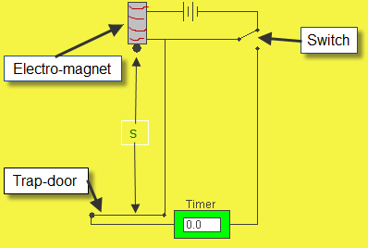**Draw a labelled diagram of the apparatus you used.**   
   See diagram
2. **State the measurements you took during the experiment.**Distance and time
3. **Describe how you took these measurements.**   
   *s* corresponds to the distance from the bottom of the ball to the top of the trap door.

The millisecond timer starts when the ball is released and stops when the ball hits the trapdoor.

1. **How did you calculate a value for *g* from your measurements?**

Substitute the values for s and t into the equation s = (*g*/2) t2.

1. **Give one precaution that you took to get an accurate result.**  
   use the smallest time value recorded for *t*, repeat the experiment a number of times

**2013 no.2**

1. **Draw a labelled diagram of the apparatus used in the experiment.**

See diagram

1. **How did the student prepare the ice for the experiment?**   
   It was crushed and then dried.
2. **How did the student know that the ice was at 0 °C?**It was melting
3. **How did the student find the mass of the ice?**   
   Subtract initial mass of calorimeter and water from final mass of calorimeter and water and melted ice
4. Why did the student use warm water in the experiment?   
   So that the heat lost to the environment when the system is above room temperature cancels out the heat taken in from the environment when the system is below room temperature.
5. **What precaution did the student take when adding the ice to the water?**  
   avoid splashing//did it quickly//added lots of ice//stir,

**2013 no.3**

1. **Draw a labelled diagram of the apparatus that the student used in the experiment.**

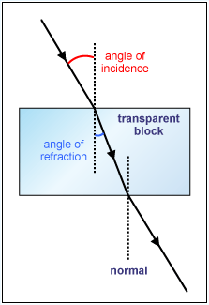See diagram plus ray box

1. **What measurements did the student take?**   
   Angle of incidence plus angle of refraction
2. **How were these measurements used to calculate the refractive index of the substance?**   
   n = sin i/ sin r
3. **Why did the student repeat the experiment?**  
   To get an average value (for increased accuracy)

**2013 no.4**

1. **Draw a labelled diagram of the apparatus used in the experiment.**

See diagram

1. **How did the student measure the resistance of the thermistor?**

Using an ohmmeter or a multimeter set to read ohms.

1. 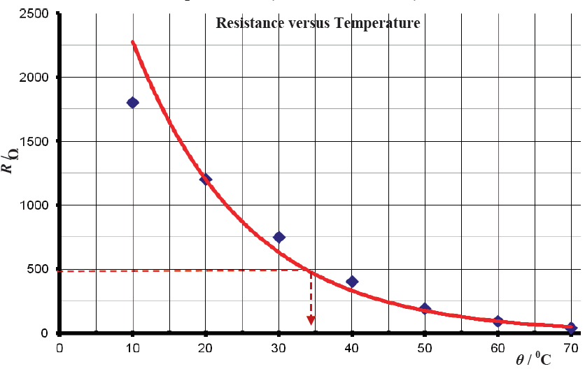**Plot a graph on graph paper to show the relationship between resistance *R* of the thermistor and the temperature *θ*. (Put *θ* on the *X*-axis.)**See graph
2. **Use the graph to estimate the temperature of the thermistor when its resistance is 500 Ω.**

34 0C to 37 0C

1. **What can you tell from the graph about the relationship between the resistance of a thermistor and its temperature?**Resistance goes down as temperature goes up.

**2013 no.5**

1. **Give an example of (i) a vector quantity, (ii) a scalar quantity.**

Vector: Velocity, acceleration, force etc

Scalar: Time, mass, speed etc

1. **The spanner shown in the diagram is used to turn a nut.**

**Calculate the moment of the force applied by the spanner to the nut.**

50 × 0.1 = 5 N m

1. **Which of the following scientists is associated with the discovery of the structure of the atom?**

**Einstein Rutherford Faraday Coulomb**

Rutherford

1. **What is meant by the threshold of hearing?**

The threshold of hearing is the smallest sound intensity detectable by the average human ear at a frequency of one thousand Hertz.

1. **How does light travel through an optical fibre?**  
   By total internal reflection
2. **Give a common use for a convex lens.**

Magnification, (eye) glasses, binoculars, contact lenses, camera, etc.

1. **What colour is the wire that is connected to the fuse in a standard three-pin plug?**

Brown

1. **Give a common use for a capacitor.**

Store charge / conducts a.c. /(radio) tuning / filtering / smoothing / timing / store energy / flash camera / phone charger, etc.

1. **What is the photoelectric effect?**

The Photoelectric Effect is the emission of electrons from a metal due to electromagnetic radiation of a suitable frequency falling upon it.

1. **Name one method for detecting radioactive particles.**  
   Geiger-Muller tube, Geiger counter, solid state detector, cloud chamber, bubble chamber, GLE, photographic film, radioactive sensor, etc.

**2013 no.6**

1. **Define momentum**Momentum is mass multiplied by velocity
2. **Define force**   
   Force is that which can cause an object to accelerate.
3. **State the principle of conservation of momentum.**Total momentum before an interaction equals total momentum after an interaction, provided no external forces.
4. **Explain how the principle of conservation of momentum applies in the case of a jet engine moving an aircraft.**   
   Backward momentum of the expelled gas equals the forward momentum of the aircraft.
5. **Calculate the momentum of the truck and the car before the collision.**   
   Only the truck is moving so the only velocity is associated with the truck: 5000 × 10 = 50000 kg ms-1
6. **What is the momentum of the combined vehicles after the collision?**  
   50000 kg ms-1
7. **Calculate the velocity of the combined vehicles after the collision.**50000 ÷ 6000 = 8.3 m s-1.
8. **What is the momentum of the truck after the collision?**  
   (8.3 × 5000) = 41 500 kg m s−1
9. **If the collision between the truck and the car takes 0.3 seconds, calculate the force exerted by the truck on the car.**Force equals rate of change of momentum = [(mu – mv)÷time] = [(50000 – 41500) ÷ 0.3] = 27.8 kN
10. **Explain why the airbag reduces the risk of injury to the driver.**  
    The longer time reduced the force on the driver’s head.

**2013 no.7**

1. **What is meant by the frequency of a wave?**  
   The frequency of a wave is a measure of the number of oscillations (vibrations) of the wave per second.
2. **Give the relationship between the frequency and the wavelength of a wave.**   
   v = f λ
3. **What will the student notice as he moves from A to B?**   
   The sound level increases and decreases
4. **Name this phenomenon.**   
   Interference
5. **Explain with the aid of a diagram how this phenomenon occurs.**

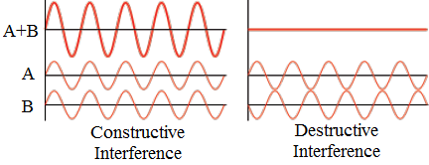

1. **Why should this phenomenon be taken into account in the placing of speakers in theatres or auditoriums?**

So that all areas of the auditorium have the same level of loudness.

1. **Explain the term fundamental frequency.**The lowest resonant frequency of a vibrating object is called its *fundamental frequency*.
2. **What are overtones**?  
   Overtones are multiples of the fundamental frequency
3. **How can the note produced by a guitar string be changed?**   
   Change the tension or length
4. **What is resonance?**  
   Resonance is the transfer of energy so that a body vibrates at its natural frequency.

**2013 no.8**

1. **Name the unit of current.**

The amp

1. **Give an example of a conductor.**   
   Copper
2. **Name a source of potential difference.**A battery / power supply
3. **What are the charge carriers in semiconductors?**Electrons and holes
4. **What type of conductor does the I-V graph in the diagram represent?**

Metallic / ohmic

1. **What is a magnetic field?**   
   A region in space where a magnetic field is felt.
2. 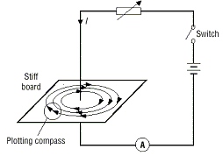**Describe an experiment to show that a long straight wire carrying a current has a magnetic field.***apparatus*; battery / power supply, plotting compass

*procedure*; turn on the current

*observation/conclusion*: compass direction changes

1. **Sketch the magnetic field.**See diagram
2. **Give an application of the magnetic field due to a current.**  
   Electromagnet, speaker, motor, induction coil, transformer, etc

**2013 no.9**

1. **What is heat?**   
   Heat is a form of energy
2. **Name the three ways in which heat can be transferred.**   
   Conduction, convection and radiation
3. **Describe an experiment to show how heat is transferred in a liquid.**   
   *apparatus;* liquid in glass beaker, heat source, (solid) dye   
   *procedure;* put the dye in the liquid and heat   
   *observation/conclusion*; the dye can be seen rising to the top of the liquid.
4. **How does the method of heat transfer in a liquid affect the positioning of the heating element in a kettle?**   
   The heat rises so the element is at the bottom.
5. **Why is the handle of a kettle made of an insulating material?**   
   An insulator doesn’t conduct heat so is safe to touch.
6. **Name an insulator suitable for use in the handle of a kettle.**

Plastic or wood

1. **Calculate the energy gained by the water.***E* = *mcΔθ* = (1.3)(4200)(80-10) = 3.8 ×105 J
2. **Calculate the power rating of the kettle, assuming all of the electrical energy is used to heat the water.***P* = Energy/time = 3.8 ×105 / 180 = 2123.3 W

**2013 no.10**

1. **What are X-rays?**

High frequency electromagnetic radiation

1. **State a property of X-rays that makes them suitable for medical use.**   
   Very energetic
2. **Give a use, other than medical, for X-rays.**   
   Airport security, X-ray telescopes/astronomy, weld/art inspection,
3. Draw a labelled diagram showing the main parts of an X-ray tube.

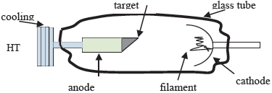

1. **How are electrons produced in an X-ray tube?**

Thermionic emission

1. **What is the purpose of the high voltage in an X-ray tube?**

To accelerate the electrons

1. **What happens when the electrons hit the target in an X-ray tube?**

X-rays are produced

1. Name a suitable material for use as the target.

Tungsten

1. **Give one safety precaution required when using X-rays.**Use protective clothing, use a lead shield

**2013 no.11**

* 1. **What are the key components of the national grid?**  
     Network of high voltage transmission stations and high voltage power lines
  2. **Why are high voltages used to transmit power over the national grid?**To avoid energy losses associated with high currents
  3. **Why is the power supplied to domestic customers at lower voltages?**

It is safer

* 1. **Name two renewable and two non-renewable energy sources used to generate electricity.**  
     renewable : wind, solar, wave, hydroelectric, biomass, geothermal etc.

non-renewable: coal, oil, peat, gas, nuclear etc

* 1. **The national grid uses alternating current (a.c.) rather than direct current (d.c.).**

**What is the difference between them?**  
a.c. changes direction; d.c. does not

* 1. **Name the device used to convert high voltages to lower voltages.**  
     Step-down transformer
  2. **Give the principle of operation of the device named in the previous question.**  
     Electromagnetic induction
  3. **Name the unit of electrical energy that is used in the delivery of electricity to homes and businesses.**  
     The kilowatt-hour

**2013 no.12 (a)**

1. **Define pressure.**   
   Pressure = Force ÷ Area
2. **Describe an experiment to show that the atmosphere exerts pressure.**   
   *apparatus*: can (containing water) // can (of air) // glass of water

*procedure*: boil water in can // pump // cardboard / lid seal / invert in cold water // air out // invert *observation/conclusion*: can crushes / collapses

1. **Calculate the decrease in pressure on the diver as she swims upwards.**   
   pressure due to water at 50 m**:** (*p* = *ρgh* = (103)(9.8)(50) =) 4.9 ×105 Pa   
   pressure due to water at 20 m**:** (*p* = *ρgh* = (103)(9.8)(20) =) 1.96 ×105 Pa  
   decrease in pressure due to water**: =** 4.9 ×105 – 1.96 ×105 = 2.94 ×105 Pa

**2013 no.12 (b)**

1. **What is meant by dispersion?**   
   Dispersion is the splitting of light into its constituent colours.
2. **What is observed on the screen between X and Y?**   
   A spectrum
3. **What information does dispersion give about the nature of white light?**That it is made up of different colours.
4. **Give another method for the dispersion of light.**Shine light through a diffraction grating.
5. **Give an everyday example of the dispersion of light.**  
   A rainbow

**2013 no.12 (c)**

1. **State Coulomb’s law of force between electric charges.**

Coulomb’s Law states that the force between two point charges is proportional to the product of the charges and inversely proportional to the square of the distance between them.

1. **Give a use for an electroscope.**
2. To detect charge
3. To distinguish between positive and negative charge
4. To indicate approximate size of a charge
5. To test if an object is a conductor or an insulator
6. **How can an electroscope be given a positive charge?**Bring a negatively charged rod close to the conductor and then earth the electroscope.

Remove the earth, then remove the rod.

1. **What is observed if you touch the cap of the electroscope with your finger?**

The leaves collapse.

1. **Explain why this happens.**  
   The charge flows to earth

**2013 no.12 (d)**

1. **What is nuclear fission?**   
   Nuclear Fission is the break-up of a large nucleus into two smaller nuclei with the release of energy and neutrons.
2. **Name a fuel used in a nuclear reactor.**   
   Plutonium, enriched uranium
3. **How can the reaction in a nuclear reactor be controlled?**

By lowering and raising the control rods.

1. **How is the energy produced in a reactor used to generate electricity?**

It is heat energy which is used to produce steam which runs a turbine.

1. **State a hazard of nuclear reactors.**  
   Nuclear contamination